**Willify Documentation**

Name: Nico Valerian Marcello  
NIM: 2702250242  
Class: LA02

Hello, welcome to my music player (Willify) website documentation. This is where I take notes of the little steps that we take during the development of the website from scratch.

1. **Project Setup**

This project will be updated regularly throughout the development process in my private GitHub repository. This enables me to work with the website on any other machine that has Git other than my work laptop. The project has been set up with subdirectories to organize the files needed for the website. Here is what it looks like so far:

The CSS and JavaScript files are located inside the src/ folder, this documentation is located inside the docs/ folder and the entire Figma mockup which we will cover next is in the figma mockup/ folder.

1. **Prototyping**

Prototyping is done entirely through Figma, where we design the mockup from scratch. The mockup is mainly made up of 5 main pages: home, songs, register, about us, and song detail. Here is how the bare mockup looks like:

Now, I am working on the navigation bar (navbar) for unregistered users, we will use auto layout features provided by Figma to organize the navbar. The logo is just temporary; it is currently a work in progress.

Here is the registered version of the navigation bar, which includes the profile picture for the user (which is just a blank gray circle as a placeholder):

Next, I continue adding background and title for the homepage. The background is a linear gradient like Spotify’s background style.

I made sure that the navigation bar has fixed position so that when users scroll down, it stays on top of the page. I also added a features frame below the “Start for Free” button.

Added recommendation songs below in the forms of cards.

Finally, I added a simple and sleek footer for the website. This pretty much wraps up the Figma prototype for the homepage.

Next, I added a simple registration page in the mockup. Here is how it looks like: 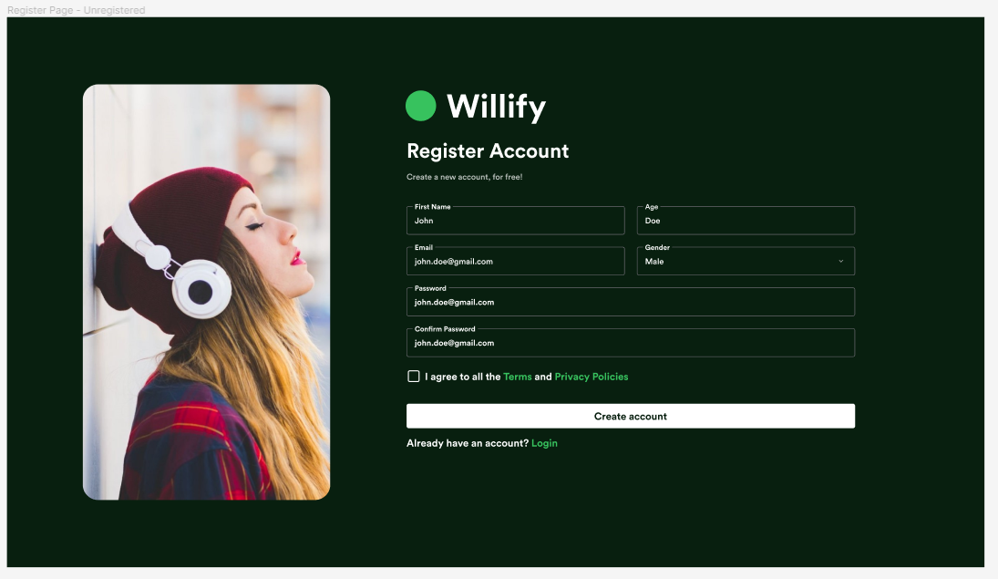

After that, I made the “Songs Page” mockup that shares a lot of similar elements to the song cards in the “Home Page”. Here is how it looks:

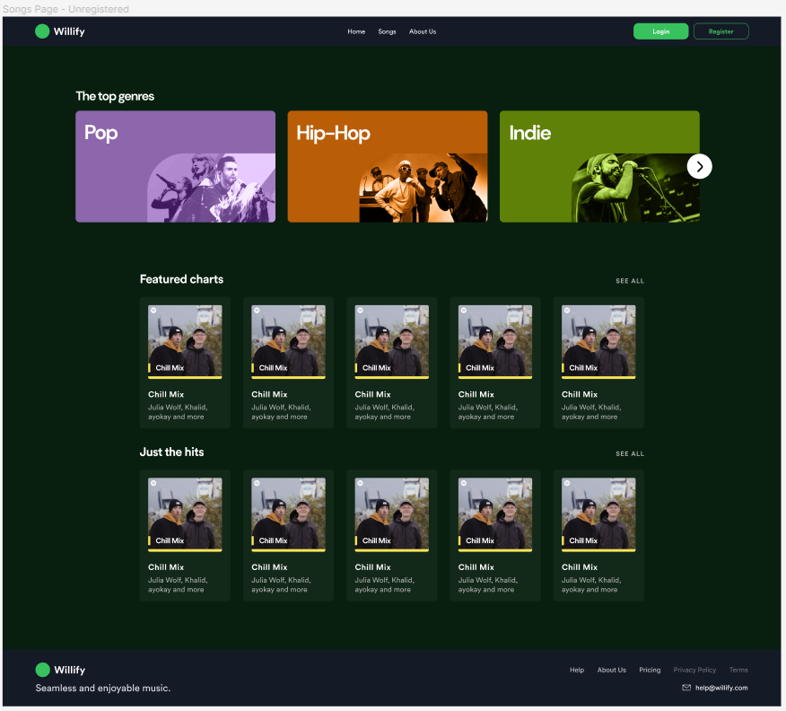

Before making the “Song Details Page”, I made the “About Us Page” mockup, it looks simple yet delivers the message effectively:

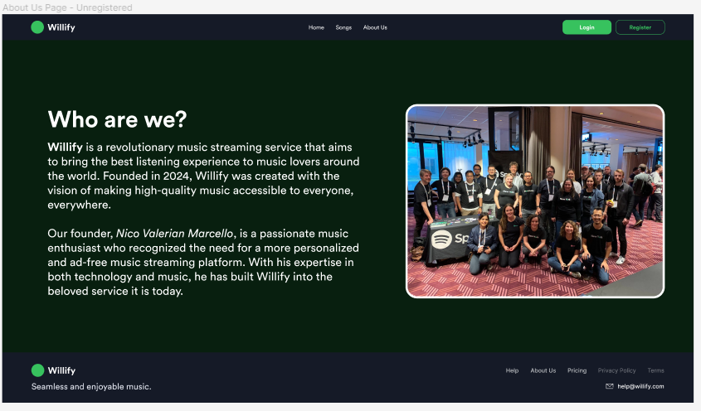

Lastly, to put more details in every Willify’s songs, we will create a “Song Details Page” for every song. Here is how it looks like:

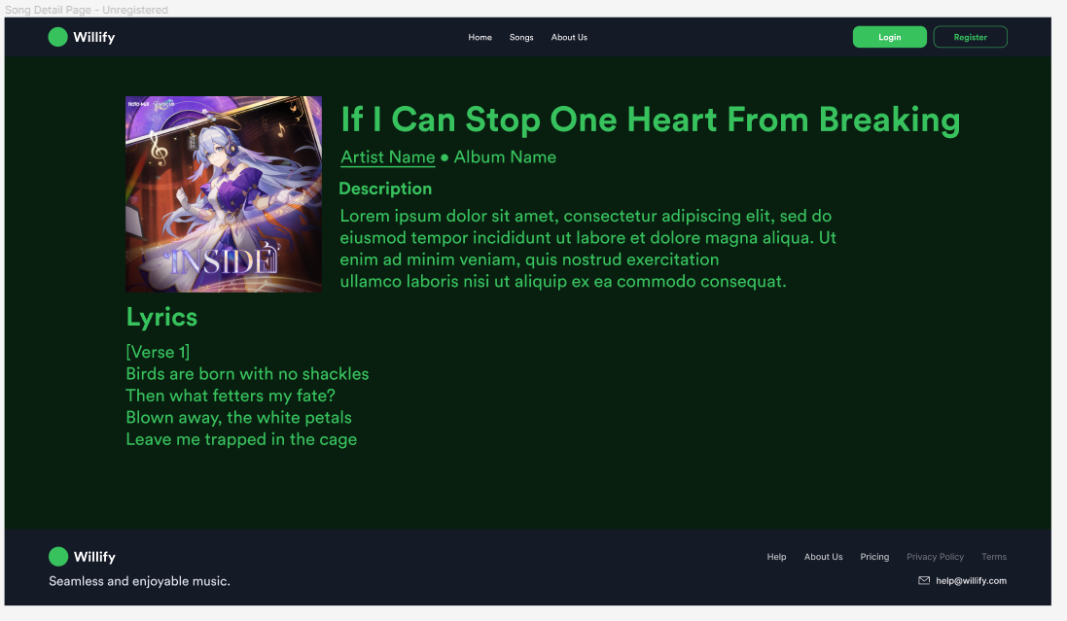

After making the entire desktop mockup and adding prototyping features (navigate to other page when button clicked, etc.), we can get to actually making the website in code. We will start by writing semantic HTML for the homepage then style everything with CSS and add media queries for other screen sizes. Also, for now, we won’t need to code any JavaScript logic for our static homepage.